Gloucestershire County Council
Adult Social Care
Care Quality Commission Self-Assessment
May 2024
Easy Read Report



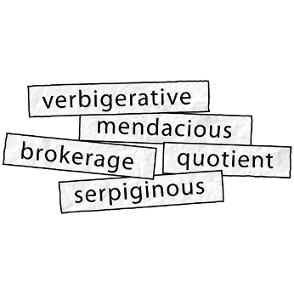

Some of the hard words in this report are in BOLD, you can find out what they mean at the end of the report.


Introduction.
Our self-assessment report shows how we are doing in Adult Social Care in Gloucestershire.

A self- assessment is a way of checking how we are doing. Here are some of the ways we pulled together our self-assessment:
- Looking closely at our services.

- Asking people who use our services what they think.
- Talking to groups and organisations we work with.
- Talking to our staff teams and managers.
- Checking the information we have collected about how well we are doing.
- Checking how our work has made a difference to people in Gloucestershire.
- Asking people who work in Adult Social Care from outside Gloucestershire to come and look closely at the way we do our work. This is called a Peer Challenge.


- We used this information to help us think about,
- What we are doing well,
- What needs to be better.
- It has helped us decide on the things we need to do.


What is Adult Social Care?
Adult Social care refers to the support and help provided to people over the age of 18 to,

- Live independently and stop problems before they start, or stop them from getting worse as early as possible (this is called prevention).
- Provide information and advice to help people choose the right care and support.
- Stay safe and well.
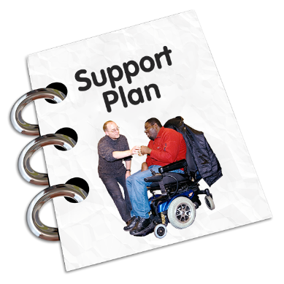
- Support people providing care to family.

The support social care offers can be broken down into short term, this means support for an agreed amount of time,
and long term, which means support will carry on as long as it is needed.
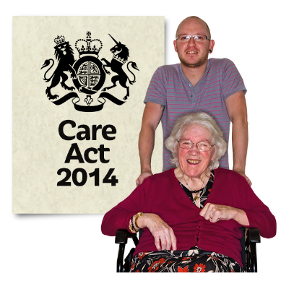
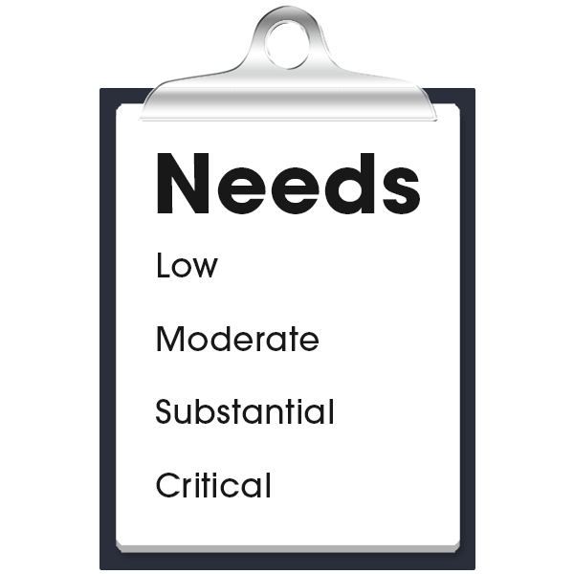
What do Adult Social Care do?
Gloucestershire County Council are responsible for assessing people’s needs and must always think about Well-being (this is under the Care Act, 2014).

We must involve you in assessments and in planning, as well as checking your care and support.


If you find this difficult and there is no one else to speak for you we must find you an independent advocate.


The Council is also responsible for the Care provider Market and have to make sure that people’s needs are met if their care provider can no longer provide care because of business failure.

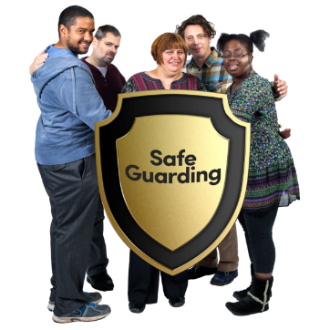
To help us we buy care packages (broker) and commission providers to meet different needs.

The Council is also responsible for helping to keep vulnerable adults safe from abuse or neglect.


What will CQC be assessing Adult Social Care on?
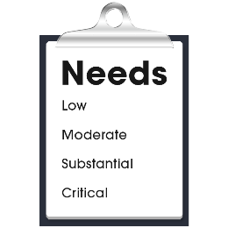

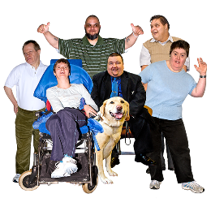

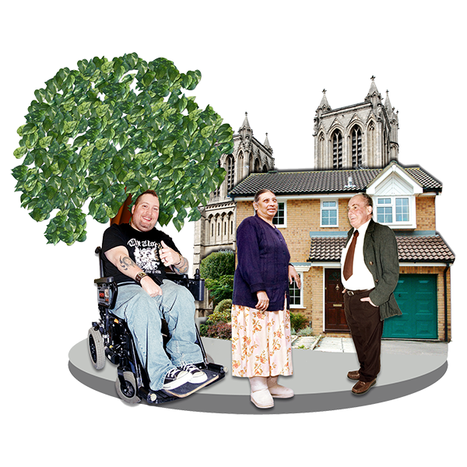
The Care Quality Commission will be assessing nine areas of our work.

- Assessing Need – this is about how we find out about the help and support people need.

- Supporting people to live healthier lives – this about the way we help people stay healthy and have a good life.

- Equity in experience and outcomes – this is about how we make sure people from different groups can get help in a way that is fair.

- Care provision – this is about the different services people can have help and support from.

- Partnership and communities – this is about how we work together with other organisations, groups and communities.


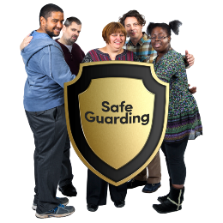
- Safeguarding – this is about the way we work with people to stay safe from abuse and neglect.

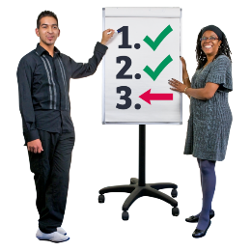
- Safe systems, governance and management – this is about how we make sure we are doing all of our work well and how we check how we are doing.


- Improvement and innovation – this is about how we make what we do better and how we try new ways of doing things to make our services better.

- Governance and leadership – this is about how we manage and deliver good quality and sustainable care and support.


What we found out.
Things we are doing well.
The people who are in charge of the Council know how important it is to have good support from Adult Social Care for people in Gloucestershire.

We have lots of examples of good work in all the different things we do.

- We are doing well working together with NHS to meet people’s needs.
- We have a plan to make things better, called the Adults transformation programme and improvement plan.
- We have good ways of checking how we are doing and how we can keep getting better – this is called Governance.

We know how we are doing now and the things we need to do better.
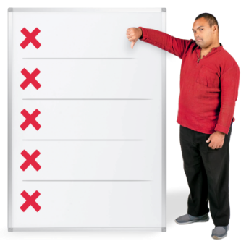
Things we need to do better.
We need to have better ways of checking how we are doing in important areas of our work.


We have not been doing this well which means we have had lots of different work going on and we have found it hard to check whether what we are doing is making a difference for people.

We have already started to work on this by having a more organised way to decide what are the important things we need to work on first.


We need to work on the way we keep a check on things like,
- how we collect information and use it to understand how well we doing,
- how we make our big plans for Adult Social Care and manage them,
- how we use technology to help keep people safe and support them in their lives.

We need to keep working on our relationships with groups and organisations across Gloucestershire so we can make sure we can meet all responsibilities we have from the Care Act 2014.
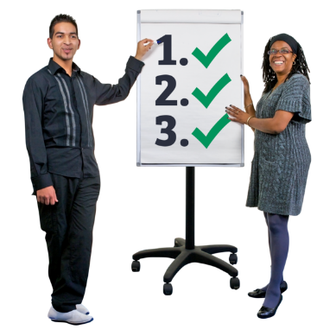
We have used our self-assessment to say what we want to do. We call this Our Mission and the things we think are most important to do first, we call these Our Priorities.
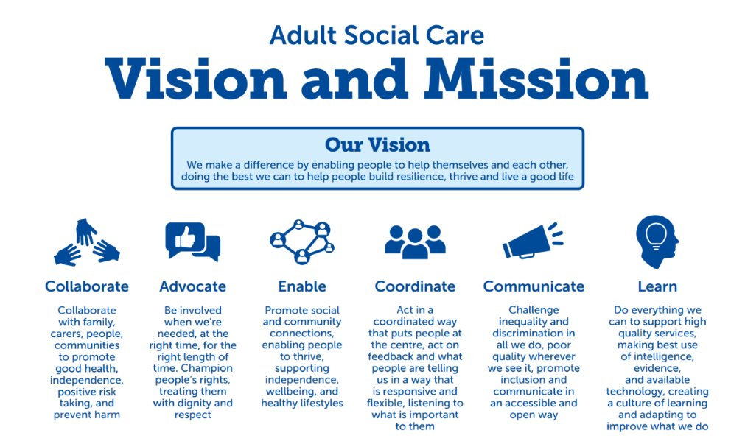
What we want to do – Our Mission.


What does this mean for people?


- Collaborate – this means we will work together with families, carers, people and communities to help people live safe, healthy and independent lives.

- Advocate – this means we will treat people with respect support them to get help at the right time.
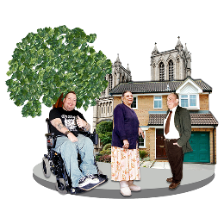
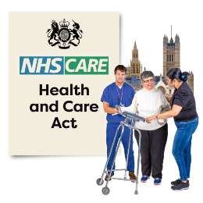
- Enable – this means we will make sure people know about things in their community that can help them live healthy, independent lives.

- Co-ordinate - this means we will work together with other services like the NHS and listen to what is important to people when they need help and support.

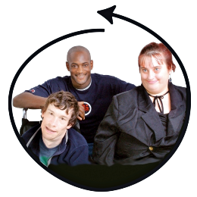
- Communicate - this means we will challenge things that are not fair or not good enough and make sure people are included through things like, good communication that is right for the person.
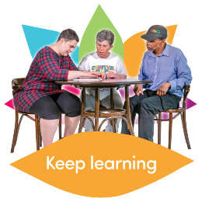
- Learn - this means we will use the information we get about our work to help us make sure it is good quality and learn how we can make what we do better.

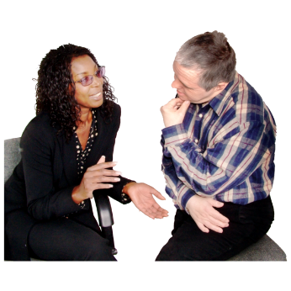
Things we think are most important to do first –
Our Priorities.

- Fit for the Future – this is what we call our plan to make sure the way we do assessments and support people is right for them, in the right place at the right time.

- Co – production – this means we want to be even better at working together with people with lived experience of disability and long term conditions when we are planning or looking at services.

- Future focussed – this means looking forward to make sure the way we use technology is safe and when we change how we do things, we do it safely.

- Prevention and early help – this means doing work on how we can support people so they might not need services, need fewer services or do not need them as soon as they might have.

- Supported skilled and flexible workforce – this means working with care providers to be able to employ more care staff and then give them the right skills to support people.


- Prioritise – this means deciding what things we need to work on first when we are thinking about the services we buy and how we support providers and new ideas.

- Partnership working – this means working together to do the things we need to, to support health in the work they are doing about urgent and emergency care.



- Data and quality - this means doing the things in our plan about information and quality so we can keep a check on them and make good decisions about what we need to do.

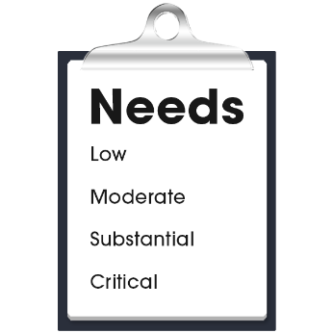
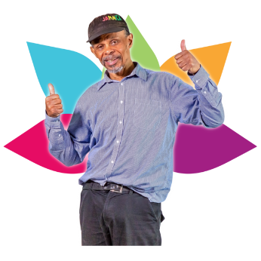
This is what some of the hard words in our report mean.
Prevention | Prevention services are for everyone, not just people who need care and support.  These services help people so they can carry on doing things for themselves and stay healthy.

Assessing | This is the way we find out about the things a person can do for themselves and the care and support they may need.  Carers can also have an assessment about the help they may need.
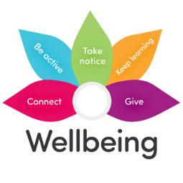
Well-being | Well-being is about feeling healthy and good about your life.

Independent Advocate | An Advocate is someone from outside social care who understands what is important to you and speaks up for you or helps you to speak up for yourself.

Care provider market | This is a group of organisations who provide care and support.

Business failure | This is when a care provider is not able to carry on running their business because something has gone wrong.

Broker and commission | These are the ways we make sure there are the right support services for people.  This could mean agreeing a contract with another organisation to provide support for people.


Abuse | Abuse is when someone hurts or uses you, this could be things like hitting you, or stealing your money or making you have sex when you do not want to.  There are lots of different kinds of abuse.

Neglect | This can be things like not having enough food, not being helped to stay clean or take medication or not being cared for properly.


Sustainable | This means making sure that services for people have the things in place to make sure they can keep providing care and support.  This could be things like plans for the future or how they will make sure they have enough care staff.

Independent | Being independent means being able to do things for yourself.


Created by EaRWIG
Easy Read With Inclusion Gloucestershire info@inclusion-glos.org

