The Learning Environment: The Social and Emotional Environment
Calm and quiet spaces
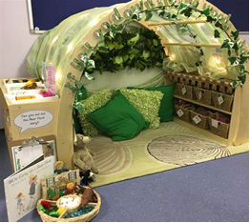
A calm and quiet space provides an area where children can take a break from the busy environment. This is beneficial when a child is feeling overwhelmed or upset, this space gives them an opportunity to regulate their emotions. Children can use this space to take time to think and rest.
Things to consider
- A cosy area should be placed in a quieter area of the room and offer a feeling of being sheltered and peaceful yet always being accessible.
- Avoid having the cosy area next to the busiest, noisiest areas where possible.
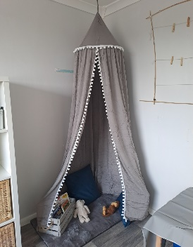
- Use canopies, netting, hanging material, dividers or tents – Hanging materials from the ceiling above a cosy area can provide a sense of safety. Make sure hanging materials are fitted properly to avoid health and safety risks.
- Provide beanbags, cushions, pillows – so children can lie down, be comfy and recharge ready to return to their play.
- Lighting – Fairy lights, bubble tubes can be added to this area. Consider health and safety risks.
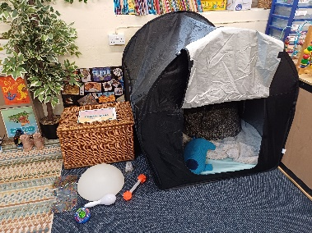
- Books – books about emotions or families are fine to have in the cosy area to offer a sense of security and develop an awareness of feelings. Books using photos of activities and experiences the children have whilst attending the setting might also be nice to use.
- Sensory toys – can be explored independently giving the children a calming sensory experience,
- Treasure baskets - natural, textured resources for children to explore in a relaxed calming environment.
Top tips for inclusion
- A calm and quiet area should always be accessible for all children.
- Rules may need to be introduced and limit the number of children using this area.
- Some children may need to be supported in knowing how to use these spaces.

Partnership with Parents
- Explain the purpose of calm and quiet area, and how this is beneficial to all children.
- Ask parents if they could donate soft furnishings, fairy lights or lamps (ensure these meet fire/safety regulations).
- Consider what skills parents have, do they have time to help construct an area or structure.

Helpful links and resources
Meeting Children's Sleep, Rest and Relaxation Needs in Early Childhood
Improve Your Cosy Area In Your Early Years Under 2's Room - Early Years Careers
OAP resource: adequate-quantity-of-play-resources-and-space-to-play
OAP resource: learning-areas-resources-are-positioned-appropriately

