Equalities (accessibilities) assessment

There is no current accessibility assessment for the properties, and accessibility is limited.

Areas of current concern have been highlighted below.

Library - main entrance
Main entrance is at street level, with access to the first floor via stairs and a lift which has currently been taken out of use due to frequent breakdowns.

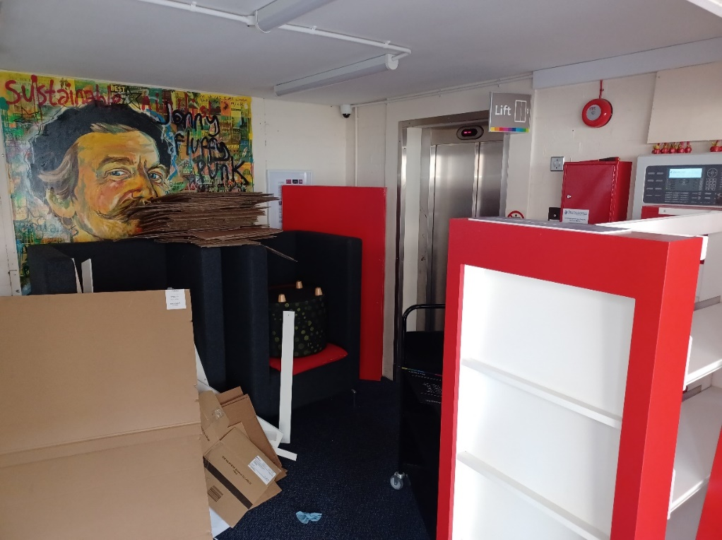

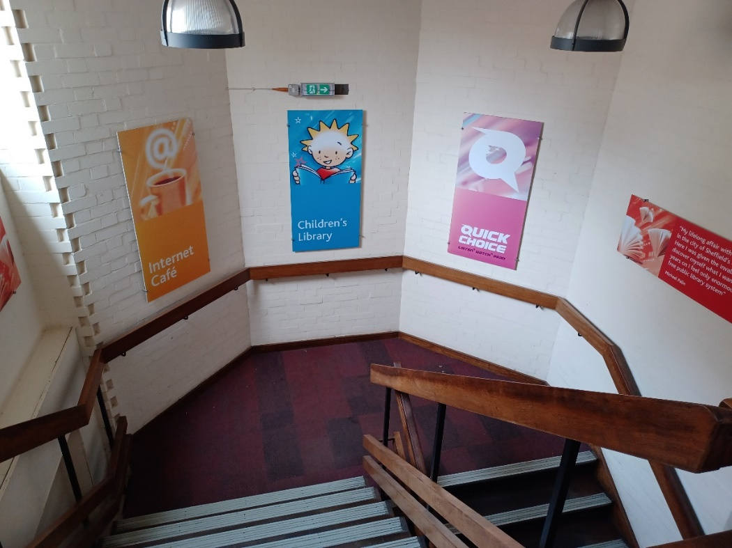

Library – staff entrance
Staff entrance is only accessible via outside stairs.
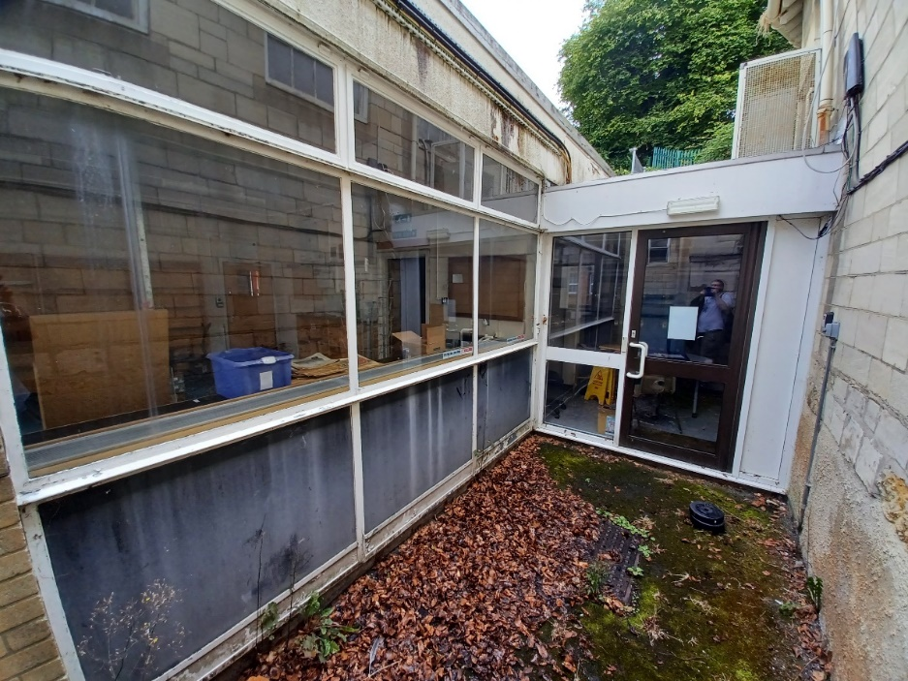

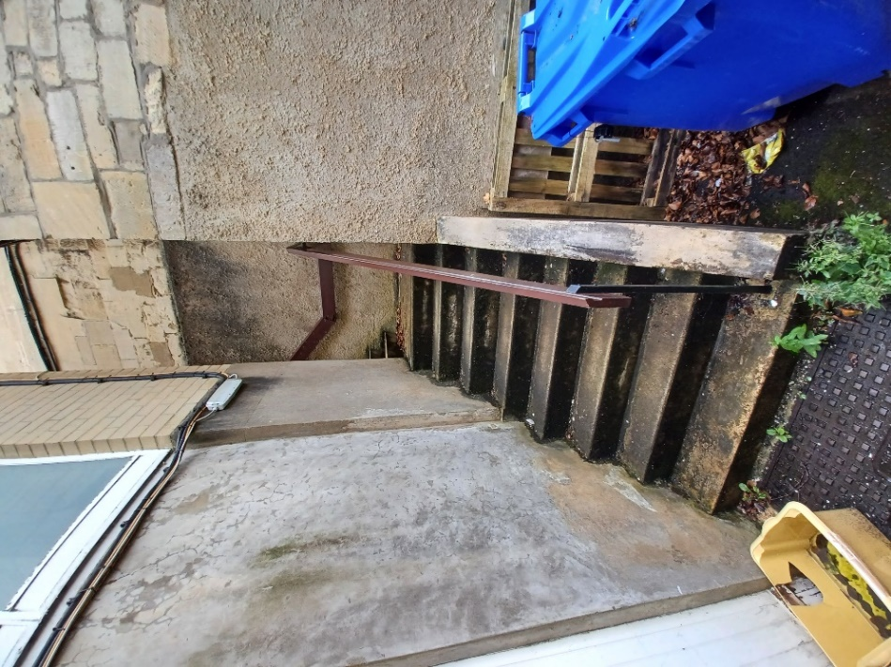

Church – ground floor entrance
Entrance is at street level, with internal steps leading to the main room.

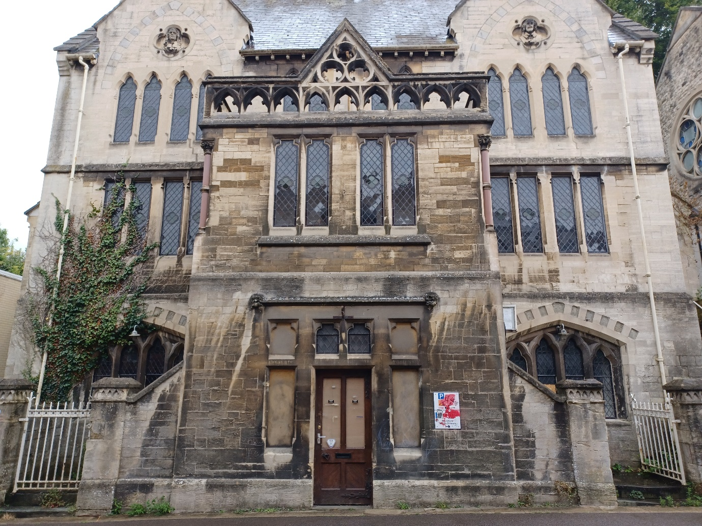

Church first floor entrances
Left and right-side doors to the first floor is only accessible via steps externally, as well as steps internally.

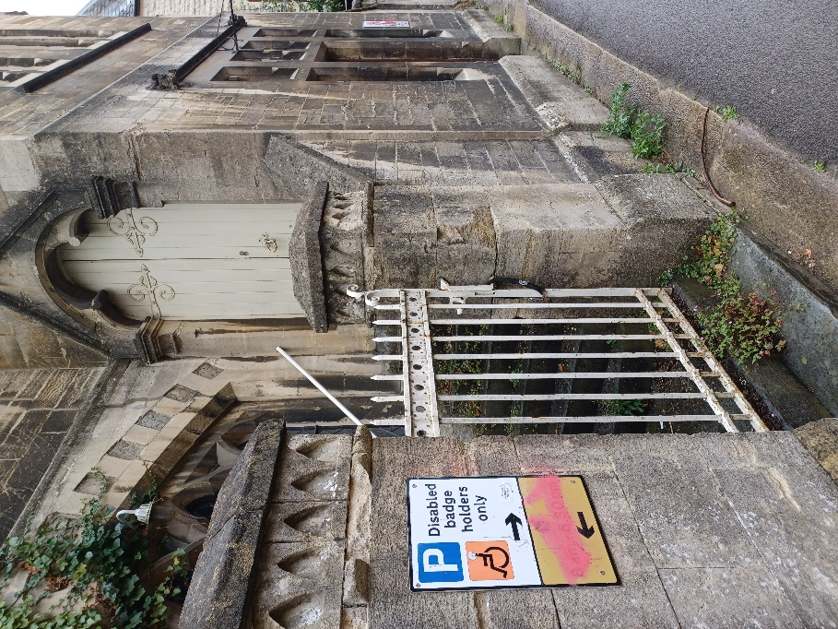

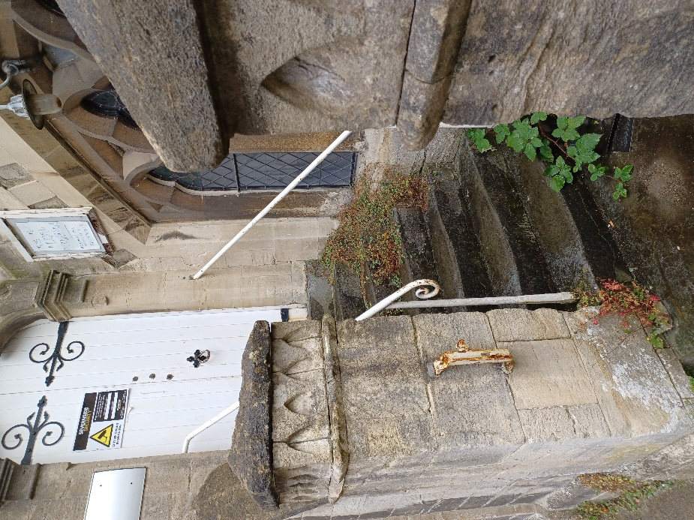
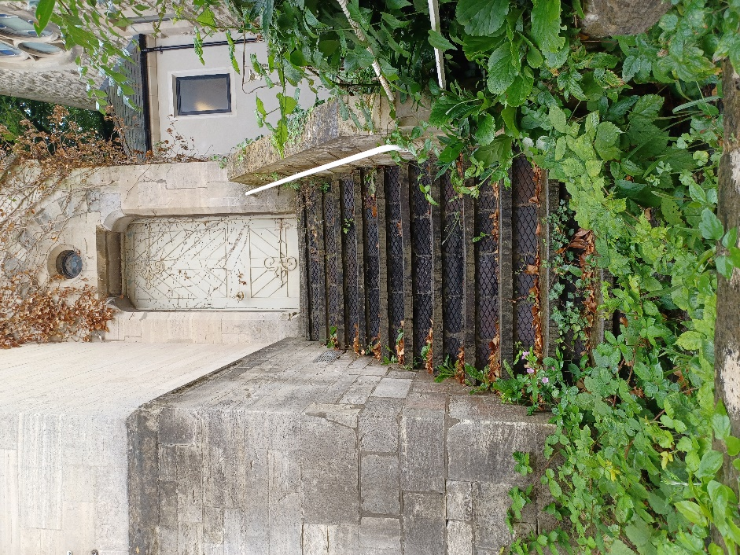

Internal view
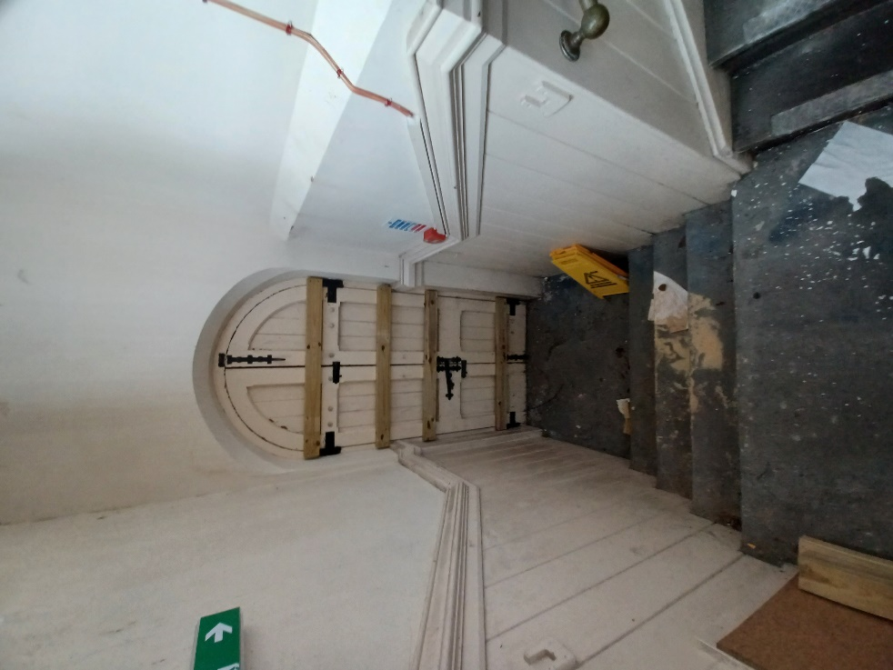

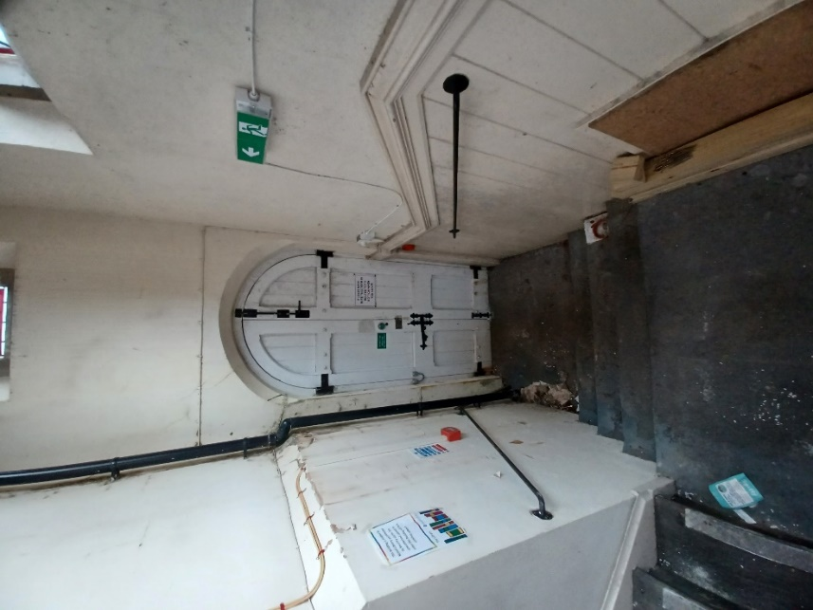
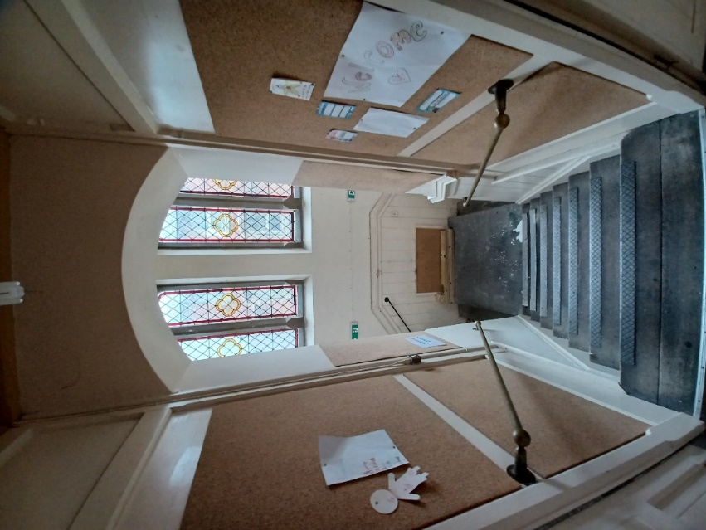

Final note
The current link between the library and the church will be removed to separate the buildings.

