Advisory Teaching Service

Useful Books for Parents / Carers and Teachers Supporting Children with SEMH Needs

Children’s core capacity for emotional intelligence is established through their experiences during the first few years of life, and emotional intelligence has been associated with academic achievement. However, some children seem to be low on emotional well being. They lack the ability to empathise, negotiate, cooperate and are unable to feel optimistic and hopeful about the future. This void may harm not only their academic development but also their personal relationships. These factors together will influence a child’s psychosocial development and can lead to behaviour problems, alienation and perhaps even aggression and violence. Literature has the potential of fostering emotional intelligence and help pupils to gain insight into human behaviour. Literature also promotes language learning by enriching a child’s vocabulary and modelling new language structures. Moreover, literature can provide a motivating and low-anxiety context for language learning.

As well as supporting pupils educationally, teachers and support staff are increasingly being called upon to help pupils who come to school with complex social emotional and mental health needs. If you’re looking for help in supporting these pupils, then a story is a good place to start. Books can help pupils to make sense of what they are feeling and provide a stepping stone to help them in talking about their problems.

Here are some books that work particularly well for this purpose.

The Bear Who Stared
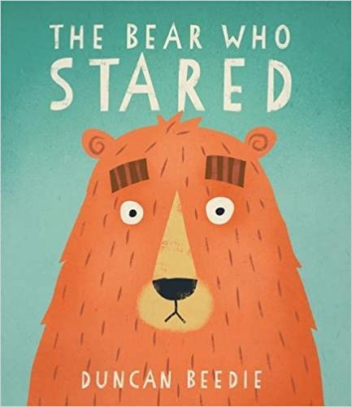
This humorous book about a socially awkward bear is great for showing pupils how they could try to make friends.

You’re a Rude Pig, Bertie!
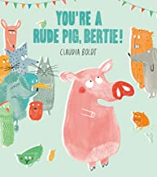
Bertie, the rude pig, is a good example of how unkind behaviour can drive away friends – and what you need to do to put things right.

Bob's Blue Period

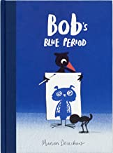
Bob's best friend Bat has to go away for a while and Bob feels so sad that he paints everything in blue. However, his other friends get together to show that there are many other beautiful colours in the world and Bob starts to feel better. A good book about expressing emotions.

Beyond the Fence by Maria Gulemetova

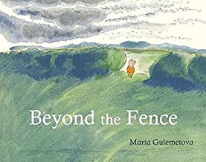
Thomas thinks he knows what's best for his friend Piggy and orders him around. Piggy becomes sad until he meets a wild pig, who helps to show him what true friendship really means.

On Sudden Hill by Linda Sarah and Benji Davies

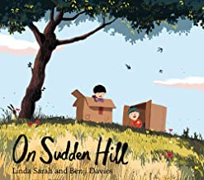

Sometimes strong friendships can break down when a new person joins the group. Try using this book for pupils struggling with playground politics or those who don’t know how to share friendships.

Willy and the Wobbly House
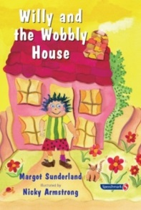
A Story for Pupils Who feel anxious or are obsessional. Willy is an anxious boy who experiences the world as a very unsafe, wobbly place where anything awful might happen at any time.

Silly Billy

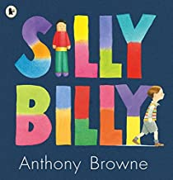
Billy worries obsessively about everything until Grandma suggests that worry dolls might help him to cope better. This book takes a sensitive and gentle approach to dealing with childhood anxiety. Many of Browne’s other books are also good for supporting discussion around emotions.

Black Dog


The youngest and bravest member of the Hope family is the only person who tames the Black Dog, a metaphor for depression, which grows bigger and bigger each time you try to ignore it. A useful book for pupils who live with parents with mental health problems.

Beautiful Oops!
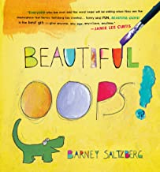
This fun book helps perfectionists to see that mistakes and accidents can actually turn into things that are quite amazing.

Ruby and the Rubbish Bin
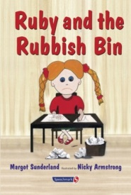
A story for children with low self-esteem. Ruby hates herself so much that she often feels more like a piece of rubbish than a little girl. She gets bullied. Sometimes, Ruby feels so miserable that she wants to sleep and sleep and never wake up again. Then one day, Ruby meets Dot the lunchtime lady, Over time, Dot helps Ruby to move from self-hate to self-respect.

Smasher
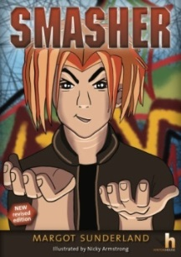
An illustrated story for adolescents and teens who suffer from anger and low self-esteem. With Manga-style artwork, this new edition will enable exploration and discussion of the difficult issues around alienation and low self-esteem that angry teenagers may be struggling with. Simon Asher, known as Smasher, bullies, gets into fights and more. At best he is heading for trouble and, at worst, jail.

Hello Happy! and No Worries! in association with Child and Family Psychotherapist Sharie Coombes

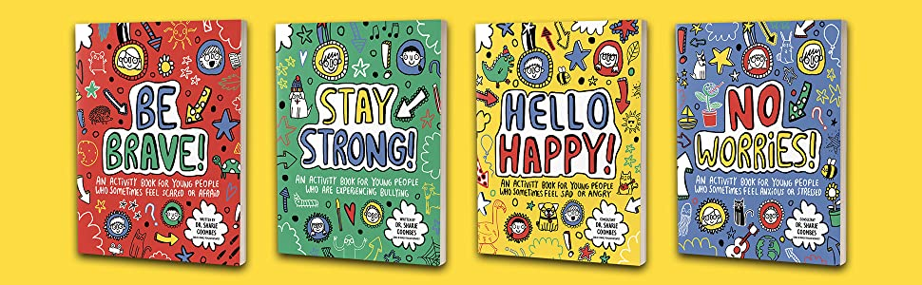
These are activity books aimed at young people who might feel sad, angry or worried. The activities include drawing what makes them happy, sad and mad, so they can discuss these things later.

The Huge Bag of Worries

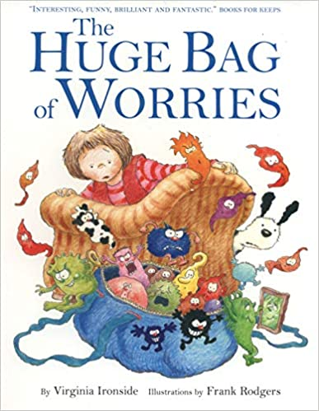
Jenny carries a huge bag of worries with her wherever she goes and is desperate for someone to help her. This book shows pupils that a problem shared is a problem halved.

Augustus and His Smile

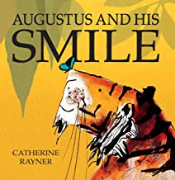
Augustus the tiger has lost his smile and is feeling sad. However, as he starts looking for it, he gradually discovers that joy can be found in all sorts of everyday situations.

Happy, Sad, Feeling Glad

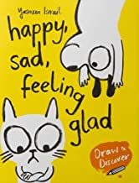

This is part picture book and part activity book. Pupils are asked to help draw illustrations of things that might make the animal characters feel happy, thereby reinforcing their own stories of good memories.

A Nifflenoo Called Nevermind
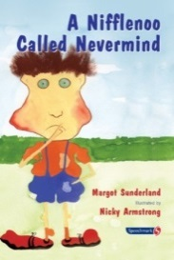
Never mind always carries on. Best foot forward, no fussing, no anger and no tears. Each time something horrible happens to him he just tucks his feelings away and carries on with his life. This way of dealing with the bad stuff that happens to him works less and less well as time goes by. Eventually he begins to understand that his feelings DO matter, and he learns to express them.

My Many Coloured Days

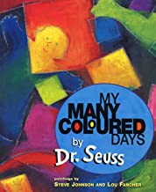
This title explores the different moods and emotions a person can feel on any given day and helps pupils understand how common those moods are and how to identify them.

The Day the Sea Went Out and Never Came Back
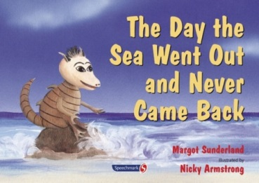
A storybook for pupils how have lost someone they love. Eric is a sand dragon who loves the sea very much. Each day, he watches it going out and coming back. His sea is beautiful indeed to him. but one day, the sea goes out and does not come back.

Conversations That Matter
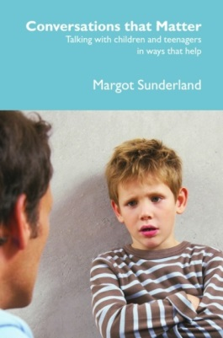
This book by Dr Margot Sunderland, offers a wealth of tools and techniques to empower practitioners and parents to connect to pupils and teenagers through conversation in life changing ways. Packed with creative possibilities, and illustrated with numerous ‘conversations’, this book can be returned to again and again whilst helping pupils and teenagers work through any painful life issue, past or present.

Draw on Your Emotions
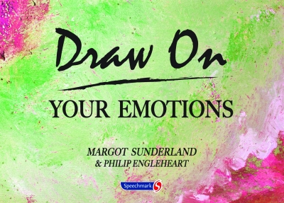
The ‘emotion worksheets’ are specifically designed to ease the process of talking about feelings. They can help promote a new clarity of thought as a first step towards positive action and bring seemingly huge, unmanageable and insoluble problems into a new perspective. The book also offers opportunities to rehearse other ways of functioning by trying out alternatives safely on paper. The exercises can be adapted for any age range and ability.

Draw on Your Relationships
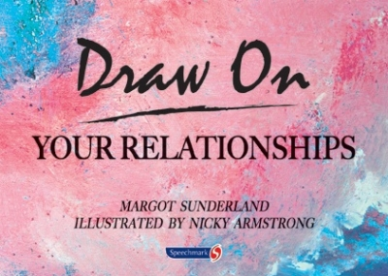
This book is designed for professionals to help pupils, teenagers and adults alike to explore, communicate and learn more about themselves in light of their relationships and so to improve their quality of life by improving their relationship life. The exercises in the book are specifically designed to ease the process of talking about relationships with the help of the pictures as openers or triggers to describe their perceptions and emotions.

Bothered: Helping teenagers talk about their feelings
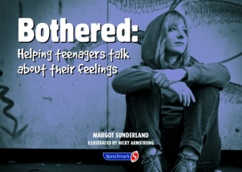
This book aims to empower people to have thoughtful, reflective conversations with teenagers about their life experiences. The book is full of tools and techniques for what to say and how to be when talking to teenagers, underpinned by research, psychology and neuroscience in adolescent development. The pictorial easy to do exercises are designed to help teenagers to develop a far greater level of self- awareness, understanding of their life, and improved self- esteem. They address key feelings, issues and concerns common to teenagers, enabling adults to talk with teenagers in a confident, non-embarrassing and effective way. The book also offers an assessment tool, 'The Teenager Well-Being Profile'.

Helping Teenagers with Anger and Low Self-Esteem
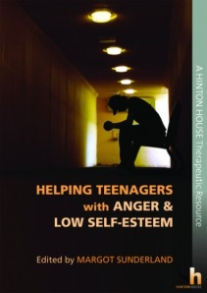
This book is a vital resource for all professionals and parents who seek to reach and help teenagers who struggle with anger, anxiety and low self-esteem. It contains vital theory and practice, tools, techniques and case studies from eminent contributors with extensive hands-on experience of working with troubled teenagers.

Helping Children with Low Self-e=Esteem
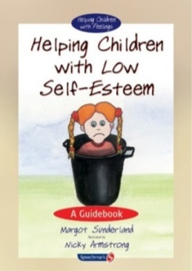
This guidebook is designed to help pupils who don't like themselves or feel there is something fundamentally wrong with them have been deeply shamed or bullied at home or at school, feel defeated by life, fundamentally unimportant, unwanted or unlovable. The book designed to enable teachers, parents and professionals to understand and acknowledge the child’s painful feelings and to respond effectively.

Helping Children Locked in Rage or Hate
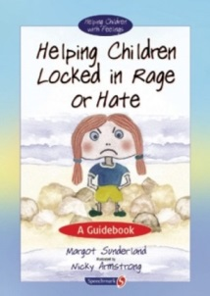
This guidebook is designed to help pupils who hurt, hit, bite, smash, kick, shout, scream or who are out of control, hyper aroused or hyperactive; pupils who can only discharge their angry feelings in verbal or physical attacks, rather than being able to reflect on what they feel, pupils who are controlling and punitive and regularly defy authority, pupils who have been diagnosed with a conduct disorder and pupils who commit cold acts of cruelty, cannot trust, have stopped looking for love or approval The book will be a resource for any child professional who works with pupils locked in rage or hate, to understand underlying causes and so to engage with the child from an informed empathic position.

Helping Children with Loss
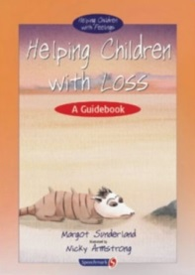
This guidebook is designed to help pupils who are suffering from the pain of loss or separation from someone they love deeply have had a parent, relative or important friend leave or die have lost someone they love, but have never really mourned are suffering from separation anxiety are adopted or fostered pupils and miss their birth parent terribly have lost their home, their country, their school, their family as they have known it (separation or divorce).

Helping Children who are Anxious or Obsessional
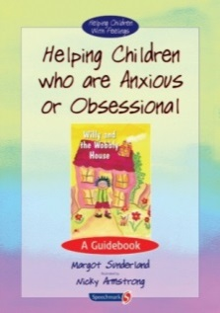
This is a guidebook to help pupils who are insecure or worry too much; suffer from phobias or nightmares; find it difficult to let go and have fun; have suffered a trauma; are worryingly good or seem like little adults"; use order and routine as a way of coping with 'messy' feelings; retreat into dullness as a way of managing being in the world; have developed obsessive-compulsive behaviour in order to ward overwhelming or unbearable feelings.

Helping Children who Bottle up their Feelings
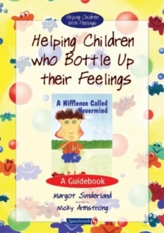
This guidebook is designed to help pupils who: bottle up their feelings; are trying to manage their too painful feelings by themselves; do not let themselves cry, protest or say that they are scared; are living with too many unresolved painful emotions from the past; have experienced disturbing, overwhelming or confusing life events, which they have been unable to think through or feel through properly; are suffering from unmourned grief. The book is designed to enable teachers, parents and professionals to understand and acknowledge pupils’s feelings and defences against those feelings and to respond effectively .The exercises, tasks and ideas for things to say and do, are specifically designed to help these pupils express and reflect on their feelings and address painful events in their lives, to the point of resolution and appropriate action.

Helping Children with Fear
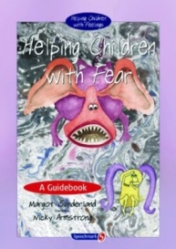
This is a guidebook to help pupils who: worry a lot experience the world as an unsafe place, suffer from phobias, obsessions or nightmares, are scared to tell someone that they are scared, know or have known a terrible loneliness, feel insignificant in a world of adult giants, feel defeated by life and need help in being assertive, feel so impotent that their only way to feel any potency is to be mute.

Helping Children Pursue Their Hopes and Dreams
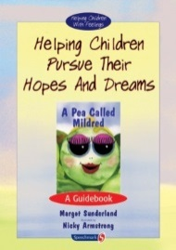
This is a guidebook to help pupils who have been given too little encouragement to follow their hopes and dreams, are too despondent or defeated to go after their hopes or their dreams. The book is designed to enable teachers, parents and professionals to understand and acknowledge the child’s feelings and to respond empathically and effectively. The exercises, tasks and ideas for things to say and do, are specifically designed to help these pupils express and reflect on their feelings and address painful events in their lives.

Literature Response Activities

The following are some suggestions for literature response activities that can both develop language skills and nurture emotional intelligence. All the activities can be adapted to the needs of the individuals and the type of literature chosen.

Scripting
This activity is best used with stories in which one of the characters is experiencing setbacks or disappointments without much support from the other characters. Pupils are invited to add script that shows what the others could have said or done to make the character feel better, and what the character could have said to the others to let them know how he or she was feeling. This activity can also be done with picture storybooks to which pupils can add speech bubbles to the illustrations.

Making others feel better
Select stories that depict situations in which emotions are clearly evident. Use illustrations from the story and encourage the pupils to identify the characters and ask how they think they are feeling. List the suggestions and ask the pupils to justify their suggestions, either based on the illustration or on what they remember from the story. Ask pupils what aspects of the picture tell something about the character’s feelings. what the other characters are doing or saying in the story. What could other characters say that would comfort or make others in the story feel better. Ask pupils to think about themselves in the position of the characters in stories. What could they possibly say to the characters that might make them feel better? Pupils can work in pairs to make up a script for an illustration from a story. This activity gets pupils to think about how others feel and what appropriate responses might be. Thus, we can teach pro-social communication. In terms of language skills, this will be a good opportunity to practice conditionals with could, should, would; for example, "What do you think they could say? What would you say?"

Sharing our own feelings
It is also important for us to learn to identify our own feelings and let others know how we feel. What could the character say so that others know how they feel? Invite pupils to work in pairs to write speech bubbles. Discuss which responses would generate the most positive feelings.

Reading body language
It is difficult to know what to do or say to people if we don’t know how they feel. We can use literature and illustrations to help pupils "read" feelings. Sometimes we can tell how a person feels just by looking at them. To teach pupils how to read body language, select an illustration from a story and then examine the body language of the characters in the illustration. How does each character’s body language show his feelings? Ask pupils how they show their disappointment.

Feeling hunt
The following activity will reinforce vocabulary that pupils need in order to express their feelings in real situations. Identify as many feelings as possible and make a list of appropriate words from the stories that pupils have read. Ask them to match the words in the list with the feelings of the characters in the stories. You can make the activity easier by also providing a list of characters.

Feelings Dictionary
Ask pupils find in the stories examples of positive expressions that demonstrate caring, empathy, tolerance, and cooperation. Have them record these expressions in a Positive Language Dictionary. They can then use these dictionaries in the other activities.

Transforming communication
Pupils will benefit from practicing expressions that reflect caring, empathy, willingness to share, and cooperation. Select excerpts in which characters experience conflict, disagreement, or sadness. Invite pupils to change the dialogue so that it reflects more positive, pro-social communication. Pupils can use their Positive Language Dictionary in this activity. Encourage sharing of dictionary entries.

What if I…?
This is an activity that requires pupils to speculate what their own emotions would be if they were in situations experienced by story characters. This works best in small groups that allow pupils an opportunity to exchange ideas about their reactions. Pupils are asked: What if I were in the situation of the character? What if this happened to me? How would I feel? Why would I feel that way? This activity fosters self-awareness by inviting pupils to provide reasons for their emotions. The groups can report to the whole class and a class discussion will help develop awareness of different ways of reacting.

Diary entries
Diary entries are especially useful in introducing a discussion about feelings. Before asking pupils to write a diary entry from a character’s point of view, discuss the story and the feelings involved. This can lead to pupils keeping their own feelings diaries and with their consent you can use their entries as a vehicle for discussion around the feelings they have experienced on particular days.

Letters/postcards to characters
Writing letters to characters is an activity ideal for getting pupils to practice positive, caring expressions. It requires the writer to infer the character’s feelings, empathise and then think about what might make the character feel better. After reading about a character who faces obstacles, pupils discuss the feelings involved. After the discussion, pupils write letters to the character, saying something that indicates they understand how the character is feeling and why, and something that might be encouraging or supportive.

Role play activities
Use role-play to get children to imagine themselves as different people in different situations (including those with physical disabilities). This will enable them to use their imagination and gain an insight into another person’s point of view. Invite them to talk through issues or conflicts as if they were the other person. Ask them to imagine what the other person would say or do. Where possible use props and costume to enhance the experience.

Hot Seating
A well know drama activity for exploring characters. Explain that when you sit in the hot seat, you are no longer ‘you’ but a different character. Once in the hot seat, the rest of the group can ask you any questions they like, which you answer in character. Of course, your character might choose not to answer some of the questions posed. Before children sit in the hot seat, discuss what questions the group might like to ask the character. Build up the tension: ‘You’re about to meet…’ You could include an item of clothing for the person in the hot seat to wear - a hat, gloves or similar. Explore the same character using several different hot-seaters - try to make sure they are all believable from the evidence in the story you’re exploring, but they might be very different.

Puppets
Puppet play is a fun way for children to learn about strong feelings. Exploring and expressing these strong emotions through the character of a puppet can help children learn how to manage emotions better. You can use any puppet or soft toy. You can even make your own. Follow the child’s lead with puppet play. Introduce emotions as part of the play.

“I” statements When setting limits we can use “I” statements.
Help children to learn safe limits to their behaviour for their own security and the safety of others. They also need to know that their feelings are understood. When this happens a child feels validated and is helped to develop a healthy sense of self.

I feel…..
When (when something happens)….
Because….
I want/would like….

Or we can be very direct

“We don’t hit. Hitting hurts.”
“I wont let you hit me. Hitting hurts.”
“We don’t bite. Biting hurts.”

Use emotion coaching techniques to let children know we recognise and understand their feelings and offer support with problem solving.

“It sounds like you are angry. I am guessing it is because I have asked you to …. Have I got that right?”

“That must be hard for you….”
I might feel like that too if….”

This kind of communication models for children a way of coping with their own feelings and provides a vocabulary for doing this. Children can learn that their feeling has a name. Going forward they can use the name to tell others how they are feeling without acting out.

Collage
Ask children to create a collage to represent the emotions shown in the story. Encourage them to search through magazines for pictures, text, images and situations that they can use. Give each group a copy of a feelings word bank that they have helped to generate while listening to or reading the story so they can cut out and paste suitable words onto their collage. Remind the children to use colours and textures that also reflect the emotion, for example red and spiked textures for anger or green and smooth textures for calm. When complete the children could describe their collage to the rest of the group/class.

Feelings games
Ask two volunteers to stand outside the classroom door. While they are outside, ask another volunteer to take a feeling word from the container and read it aloud. Ask all the children to act as if they all feel that way. Invite the two volunteers to return to the classroom and ask them to guess how the class is feeling. Repeat this game a number of times. This is an enjoyable way to help build the children’s vocabulary around feelings.

