Help with logging in and choosing or resetting your Schoolsnet password

Go to the Schoolsnet log in page: http://www.gloucestershire.gov.uk/schoolsnet/schoolsnet-login/
There is a link on the home page or log in when presented with the log in page when you browse or search the site for the information you want.
Note about the username and password. Maintained Gloucestershire schools are registered on Schoolsnet and have been issued with a username for Schoolsnet (this will start with Office916 followed by your 4 digit DfE number eg Office9161234). Schools need to set up their own password which they can reset at any time via Schoolsnet. The procedure below describes how a school can set up or reset a password.

Log in
To log in enter your username and the password you have set for new Schoolsnet.
Please note: the username and password you used on the old site (pre 30 January 2017) will not automatically work on the new site. There is now only one username (see above) and the password has to be set by the school.
If you do not know the password for your school you can choose one or reset it. Go to the log in screen and click on Forgotten your password? Remind me (highlighted in yellow below).
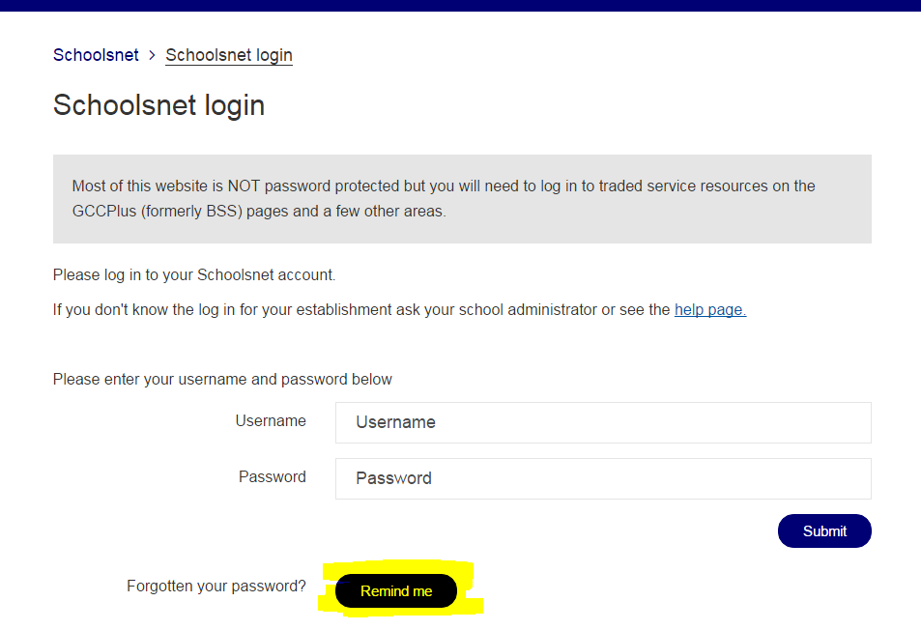

At the next screen you will be asked to enter your email address. You should use the email address we have used to register your school on Schoolsnet. This is usually the admin@ mailbox.
Please ask your school administrator which email address to use. If you are uncertain enter the most likely address. If this is incorrect system will display ‘invalid email address’ and you can try another.
Note to administrators: If you are not sure which email address you are registered with email us at digital@gloucestershire.gov.uk or phone 01452 328095 and we’ll check. You can also ask us to change the registered email but we can only accept this request from a headteacher or school administrator.
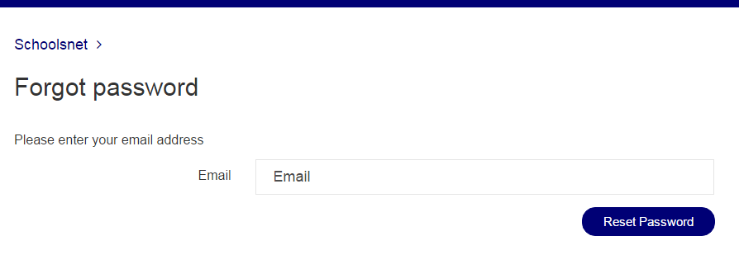
When you click the Reset Password button an email will be sent with a link to reset the password.
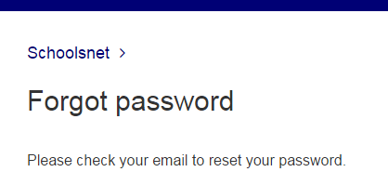
Below is an example of the email you will receive
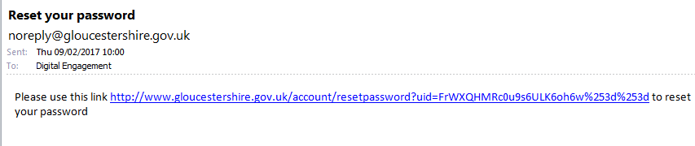
Click the link and you will be taken to the reset password screen.
Please note this screen is from the Gloucestershire County Council website but will still reset your password for Schoolsnet.
Type in a new password in the first box and confirm it in the second. Click the Save button. You are now ready to log in with the new password.
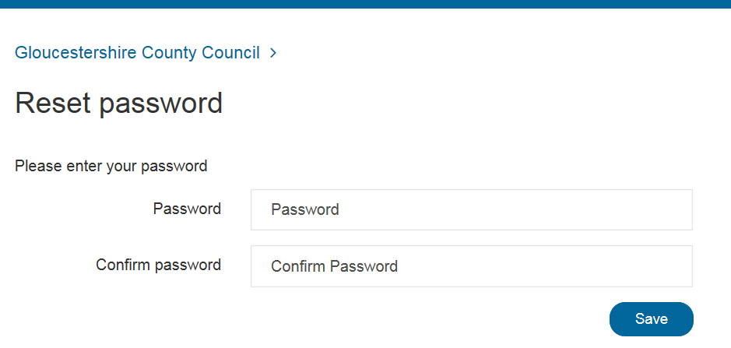

Getting locked out
You can make up to 5 attempts to log in but after that the system will lock your account. If this happens you may see a message that the user is not known.
You will need to contact us with your username so we can unlock your account.

Can’t see information
If you have logged in but can’t see information you were expecting to see this maybe because your school has not bought the service. Please contact us so we can check.#

Contact us
Either email digital@gloucestershire.gov.uk or phone 01452 328095

