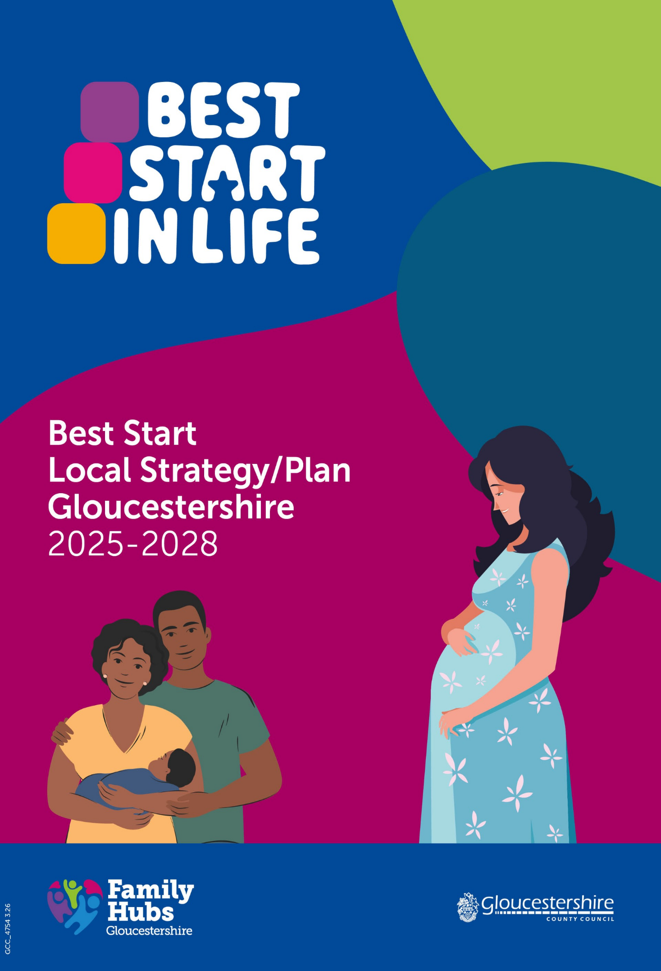
Vision

“Gloucestershire - A great place to grow up where children and young people thrive and live lives of choice and opportunity. “

Our vision is that every child grows up with the strongest foundations for lifelong learning, health and wellbeing, supported by families who have access to high‑quality, joined‑up services from pregnancy through the early years.

We are committed to service transformation that develops quality and capacity; creating a local system where support, pre-birth to 5, is easy to find, welcoming, and responsive to family needs, bringing together health, education, early help and community services. Our Best Start plan prioritises early intervention, helping families to access the right help at the right time, and ensuring no child’s life chances are limited by disadvantage or inaccessible services.

Through the development of Best Start Family Hubs we will create networks of partner organisations, united around a shared vision. Best Start Hubs will provide inclusive, integrated spaces where families can access parenting support, early learning opportunities, health services, and specialist advice, all designed to improve early development outcomes and reduce inequalities.

Our Best Start strategy also places a strong emphasis on the Healthy Babies agenda, recognising that the foundations for lifelong health, wellbeing, and learning begin from conception and continue through the earliest months of life. As part of this commitment, our local plan ensures that every baby has the best possible start through improved maternal health, responsive and nurturing early relationships, safe and supportive home environments and timely access to high-quality early help and health services.

By embedding the Healthy Babies agenda as a core area of focus, we aim to reduce inequalities from the beginning, strengthen protective factors around families, and create a coherent, place-based approach that supports babies, parents, and carers during this critical developmental period.

Our strategy will champion the value of play in the home learning environment, in the community and across all early years services. We will ensure that play is recognised, promoted and embedded as a key driver of early development—helping every child to thrive and supporting families to build strong, confident, and playful relationships from the very beginning.

We will focus on six key areas of development, informed by a strengths and gaps assessment:

- Early Education and Childcare
- Learning and school readiness and transitions
- Maternity and early health services
- Special Educational Needs (SEN)
- Parenting, Home Learning Environment and Play
- Speech, Language and Communication.
Our ambition aligns with the national mission that more children will arrive at school ready to learn and that attainment gaps for the most disadvantaged children will be reduced, with a strong home learning environment, confident parents, and improved early language, cognitive and emotional development.

Above all, our vision is to ensure that every child in our community has the best possible start in life, supported by a system that is equitable, high‑quality, and designed around the real needs of families that are also coproduced with the voices of children and families.

The ambition of Gloucestershire’s Best Start Strategy is to establish a structured, credible, data driven plan that improves outcomes for children from pre-birth to age five. The strategy will be underpinned by clear problem diagnosis, a robust intervention logic and a framework for monitoring progress.

Local context and alignment with national and local priorities

Population and Demographics
Gloucestershire has an estimated 37,885 children aged 0-5 years (GP data as of 31st August 2025). 6,042 births were recorded in the most recent dataset (ONS, 2024 Census‑based health data) providing a solid indicator of the annual intake into the 0–5 population. AI-11.2-Appendix-1-Gloucestershire-demographic-profile.pdf

These figures suggest a stable birth rate that feeds into a sizeable early years population requiring proportionate early years education, health and family support capacity.
It should be noted that population figures for 0–5s are taken from GP registered populations (August 2025), which differ slightly from resident population estimates used in the local Joint Strategic Needs Assessment (JSNA). GP data is used here as it more accurately reflects children registered with and accessing NHS services.

The reception cohort (January 2025 Census) shows that Gloucestershire’s early years population, while predominantly White British, includes significant ethnic diversity.

Ethnicity | Number | %
White British | 4,769 | 76.9%
Other White | 418 | 6.7%
Asian/Asian British | 343 | 5.5%
Mixed ethnicity | 328 | 5.3%
Black/Black British | 194 | 3.1%
Other ethnicity | 40 | 0.6%
Not obtained/refused | 108 | 1.7%

Implications for children & families: Although three quarters of children in Gloucestershire are White British, minority ethnic groups form a meaningful proportion of the early years population and may experience, language barriers, access to services, variations in immunisation uptake, higher maternal health inequalities, as well as a greater need for culturally aware communication with community-based outreach. Data reinforces the need for a Best Start system that is inclusive, culturally competent and responsive to the needs of diverse families.
Gloucestershire overall is a relatively affluent county, however pockets of significant deprivation exist — particularly in urban areas such as Gloucester, Cheltenham, and parts of the Forest of Dean. Children living in deprived areas tend to experience:

- Higher exposure to adverse material and emotional environments (poor housing, financial stress, social stress) as well as Adverse Childhood Experiences.
- Greater risk of developmental delays and Special Education Needs and Disabilities (SEND)
- Lower access to high‑quality early learning.

It is also important to highlight that children that live outside deprived wards, but in low income households will also suffer the same socio-economic inequalities. In addition, financial strain plays a significant role in shaping early childhood outcomes. Economic pressures can limit parents’ capacity to provide a rich home learning environment and are associated with higher screen use in young children, as well as increased parental stress and poorer mental health. These factors intertwine to heighten developmental risk in the early years and underline the need for joined-up, wraparound support that addresses both practical and emotional needs of families. These patterns align with national evidence that disadvantage, ethnicity and disability intersect, intensifies inequalities from birth onwards. [local.gov.uk]
For the 0‑5 population, this means that children in more deprived wards are more likely to enter the early years system with
- Lower levels of school readiness
- Higher levels of speech, language and communication needs
- Increased health inequalities and reduced access to preventative services.

Implications for the Best Start system
- Services adopt proportionate universalism, delivering universal support with greater intensity where disadvantage is highest
- Family Hubs should prioritise place-based delivery in Index of Multiple Deprivation (IMD) 1–2 neighbourhoods
- Enhanced Health Visiting engagement being essential in areas of highest deprivation
- Outreach, home visiting and community-based models are critical for equity.
Local and National strategic priority alignment
The building blocks of success are laid in the early years of a child’s life, as they begin to communicate, build relationships, play, and learn. In these early years parents need access to health, family support, and education services working hand in hand.

The Childcare Act 2006 provides a framework for early years services delivery and requires Local Authorities to:

- ensure joint working across agencies from pre-birth to five to improve outcomes and narrows the gap
- ensure that the legal entitlements for nursery education are available through the provision of sufficient care and childcare which enables families to work or undertake work related activity – Early Years (EY) and Childcare Sufficiency duty
- provide information about services and support (for both families and early years providers).

The Government strategy, Giving every child the best start in life sets out a new approach to supporting children and families from their first days of life. The aim is to make services available and accessible to families and to join up those services so that information can be shared to give children consistent support that fits their needs.

Best Start in Life explicitly links to other policy and practice initiatives, including Families First guidance, NHS 10-year plan and the link to the Neighbourhood health data which refers to the alignment of local health data, primary care registration patterns, early years health indicators, and deprivation information at small-area (ward/Lower Super Output Area/Primary Care Network) level. Linking these frameworks under a shared mission will strengthen early support for families.

National Policy Alignment

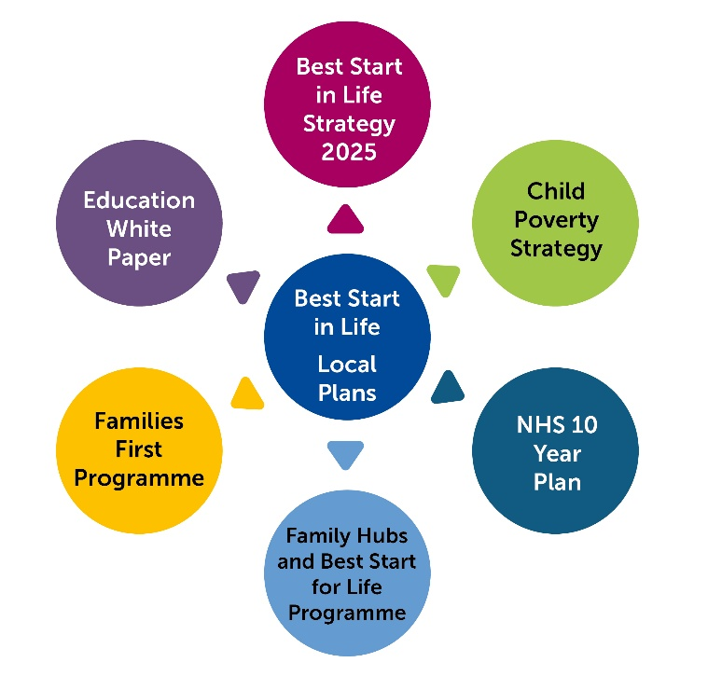

The development of our local strategy and delivery plan draws on our Children and Young People’s One Plan, aligned with our joint commissioning strategy, strategic needs assessment and SEND and Inclusion strategies.

The One Plan for Gloucestershire commits to four objectives, focused on 3 stages of a child/young person’s life: Starting Well (pre-birth to 5), Growing Well (5yrs through primary and into secondary education) and Being Well (middle teenage through post 16 years).
How we measure our success –

- Equity – Close the gap and eliminate inequalities
- Access – Right help at the right time for all children
- Inclusion – A county where everyone belongs and we celebrate diversity
- Quality – Effective, outstanding services.

Local Policy Alignment

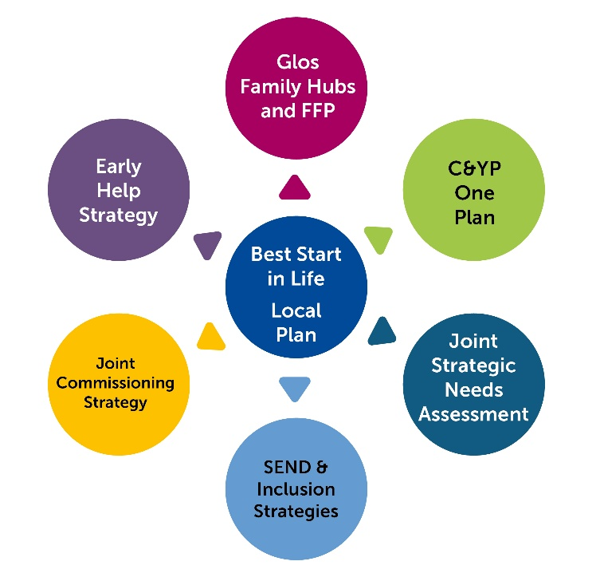

Targets
Aligned with its Best Start Strategy; the Department for Education allocated each local area a specific target to increase the percentage of children attaining a good level of development (GLD) at the end of the Early Years Foundation Stage (EYFS) by 2028.
The statutory target for Gloucestershire will be considered “achieved” if the following two conditions are met:
- The proportion of children attaining a GLD at the end of the 2027/28 academic year is at least 77.2% an increase from 68.6% in 2025 and;
- Disadvantaged children have benefitted at least equally from this improvement; that is, the proportion of children eligible for Free School Meals (FSM) and attaining a Good Level of Development at the end of the 2027/28 academic year is at least 60%, an increase from 48.4% in 2025.
To reach our overall target of 77.2% by 2028, an additional 538 children need to attain a good level of development.

To reach our free school meals EYFS target of 60% by 2028, an additional 84 children eligible for free school meals would need to attain GLD.

In addition to the Government’s allocated targets, to ensure our strategy is also focussed on narrowing EYFS attainment gaps for children from specific ethnic groups and those with special educational needs, we have set local targets to:
- Increase the percentage of Black African/Black Caribbean/Black British children attaining GLD from 59.28 to 63% by 2028. (in line with national average) This equates to an additional 11 children
- Increase the percentage of Asian/Asian British children attaining GLD from 55.01% to 62% by 2028. (in line with national average) This equates to an additional 27 children
- Increase the percentage of children with SEN support attaining GLD from 23.12% to 26% (in line with national average). This equates to an additional 20 children.
- Increase the percentage of children with an Education, Health and Care plan attaining GLD from 2.56% to 4% (in line with national average). This equates to an additional 6 children.

Summary of the current position in Gloucestershire

The strategic priorities of Gloucestershire’s local Best Start in Life plan have been shaped by the evidence gathered through our local needs assessment - Best Start Local Strategy – Case for action.
Gloucestershire’s early years system has strong universal foundations, supported by a clear strategic framework, delivery of some evidence-based programmes, a committed workforce and a developing Family Hub model.
Gloucestershire has a strong universal offer, underpinned by clear strategic direction through the One Plan for Children and Young People (2024–2030), which sets out a collective ambition to ensure all children grow up healthy, safe, included, and ready to learn. However, as highlighted across multiple needs assessments, population datasets and family insights, inequalities remain entrenched, particularly in parts of Gloucester, Cheltenham and the Forest of Dean, and among families facing socioeconomic disadvantage, additional needs, or structural barriers to access.
What is working well: Gloucestershire has a well-established and effective Early Help infrastructure that is recognised for strong multiagency collaboration with external partners and the Voluntary and Community Sector (VCS), targeted support and successful engagement with previous national programmes such as Supporting Families. This maturity is reflected in consistently achieving full Payment by Results outcomes for work with vulnerable families.
The county benefits from a longstanding experience of early help delivered across statutory, voluntary, faith and community sectors, providing a broad and diverse support ecosystem for families.
VCS organisations significantly extend the reach and diversity of Gloucestershire’s universal offer. They deliver community-based parent groups, outdoor play sessions, family wellbeing activities, and opportunities for informal peer support. Organisations such as Play Gloucestershire provide accessible play-based learning and nurture opportunities across the county, helping families engage in low cost, developmentally rich activities within their communities.
Together, Children and Family Centres (C&FCs) and the VCS form a vital universal layer of Gloucestershire’s early years system. Their combined offer promotes early relationships, supports parental confidence, strengthens the home learning environment, and ensures that families can access timely, community-based help long before needs escalate.
Within Gloucestershire, there is a clear system-wide shift towards relationship based, trauma informed, and whole family practice, supported by refreshed strategic frameworks and ongoing workforce development. This approach is improving consistency and quality of engagement across services.
Addressing disparities requires a systematic approach that aligns early years services with the four overarching One Plan objectives which include Equity, Access, Inclusion and Quality and strengthens prevention across the home learning environment, Early Childhood Education and Care settings and health services.
A more coherent, integrated and confident workforce system is needed to ensure that home learning, Early Childhood Education and Care provision and health services deliver prevention consistently, equitably and in alignment with the One Plan’s vision that Gloucestershire becomes “a great place to grow up where all children and young people thrive and live lives of choice and opportunity.”

Scale of Change
To achieve local GLD ambitions and narrow inequalities, a programme of countywide targeted uplift is required, concentrated in specific wards of the county. Data shows that Gloucestershire is on an upward trend, however disadvantaged children are not progressing at the same rate.

Children growing up in low‑income households are significantly more likely to experience compounding disadvantages, including a higher likelihood of having SEND, and of being from ethnic minority backgrounds disproportionately affected by deprivation.

Structural inequalities linked to socioeconomic status, ethnicity and disability interact to shape early childhood outcomes, with research showing that where a child is born and their family’s resources strongly predict developmental trajectories. These overlapping, intersectional factors mean that children in deprived areas often face multiple, interlocking barriers, including reduced access to high‑quality early education, greater exposure to poorer material and emotional environments, and higher risks of emotional and behavioural difficulties. As a result, inequalities appear early, widen over time, and can have long‑term impacts on health, learning, and life chances, reinforcing the need for integrated, targeted early support.

Who are our priority families?

- Children experiencing poverty or economic deprivation, where risks relating to language development, oral health and healthy weight are enhanced and transport/access barriers are more pronounced

- Children with SEND and those with emerging Speech, Language and Communication needs, requiring earlier identification, inclusive Early Years provision and smoother transitions/EHC planning

- Children in Care and Unaccompanied Asylum-Seeking Children, that experience poorer oral health and reduced access to dental care and need joined up pathways and attachment focused Home Learning Environment support

- Inclusion health groups including Roma, Gypsy and Traveller communities, and asylum seekers/refugees that face greater barriers to prevention, dental care and affordable nutritious food

- Children with English as an additional language and children from black Caribbean/African and Asian communities (reflecting national GLD trends), requiring culturally competent support and language rich environments

- Families with lower breastfeeding continuation and higher maternal BMI at booking, to optimise infant feeding and early growth and nutrition.

Where will we focus our service provision?
Although Gloucestershire performs in line with the Southwest (SW) average overall, the county’s internal inequalities mirror SW regional patterns, with poorer outcomes concentrated in Gloucester, Cheltenham, and the Forest of Dean. Across all priority districts, improving GLD outcomes, particularly for children most affected by deprivation, will be a core focus.
Primary focus
- Gloucester District: High levels of deprivation, childhood obesity, and dental decay; lower breastfeeding continuation; access challenges. Priorities include enhanced Family Hub outreach, the Supervised Toothbrushing Programme/First Dental Steps, Chat Play Read and strengthened food security initiatives
- Cheltenham District: Pockets of deprivation with elevated dental decay among 5-year-olds, lower breastfeeding prevalence and barriers to accessing high-quality play/green space and active travel routes. Priorities include strengthening Family Hub outreach, expanding oral health improvement (Supervised Toothbrushing/First Dental Steps), targeted breastfeeding support and peer networks, and enhancing access to safe play, green space and active travel initiatives
- Forest of Dean District: Rurality related access barriers (including food deserts and transport limitations) and pockets of higher obesity. Priorities include targeted outreach on healthy weight, Home Learning Environment (HLE)development and early years oral health prevention.
Secondary focus

Target neighbourhoods in Stroud and Tewkesbury where breastfeeding continuation and access to early years childcare or uptake of provision is lower, this is linked to rurality which local Gloucestershire data evidences.

Delivery Approach
The delivery of our strategy will ensure:
- Equity – targeting resources where need is greatest
- Integration – aligning partner investment and reducing duplication
- Sustainability – building long‑term models, not short‑term activity
- Prevention – shifting investment towards early intervention
- Value – ensuring measurable impact for every pound spent.
Partners across health, early education, Family Hubs and wider community services will work together as a coordinated early years system with a shared ambition to ensure every child in Gloucestershire has the best possible start in life. This integrated approach reflects the national Giving Every Child the Best Start in Life strategy, which highlights the need for joined‑up, high‑quality support from pregnancy through the early years.
Our single, countywide early years vision will guide joint planning and decision‑making, aligning priorities around improving early child development, reducing inequalities, and meeting local targets for school readiness. Education, Health and Family Hub partners will collectively monitor data on development, participation and need, ensuring there is shared accountability for progress.
Best Start Family Hubs will act as a universal “front door” and will offer a coordination point for integrated delivery, bringing together maternity, health visiting, early education, SEND pathways and family support into a single, accessible system, consistent with national guidance. Hubs will provide a coherent, culturally competent core offer that includes infant feeding, early communication and language development, parenting support, and perinatal mental health support. This integrated model will ensure families can navigate services more easily and receive timely access to high‑quality, evidence‑informed support at the earliest opportunity, irrespective of background or circumstance, preventing issues from escalating.
In parallel, the broader Family Hub network will deliver targeted, place‑based support and outreach to address inequalities and improve access for communities who experience social exclusion or barriers to engagement. This includes focused outreach into priority estates, rural communities, and inclusion health settings, with particular attention to families seeking asylum or with refugee backgrounds, and Gypsy, Roma and Traveller communities. Through partnership‑driven approaches and culturally responsive practice, the system will ensure that vulnerable and marginalised families receive tailored, accessible support that meets their needs and strengthens child and family outcomes.
The importance of play will be woven throughout the whole Best Start system, using universal and targeted touchpoints (e.g., midwifery, health visiting, family hubs, childcare providers) to encourage confident, responsive, and playful interactions between parents and children.
- Improved quality in early years provision:
Play-based learning is central to high-quality practice. By strengthening staff training, pedagogy, and environments, we will ensure settings are equipped to offer rich, developmentally appropriate play opportunities
- Strengthened pathways of support:
Incorporating play into early identification and intervention pathways will help practitioners recognise developmental needs early and work with families to address them through playful, supportive approaches
- Formal parenting programmes:
Evidence-based parenting support will embed messages about the importance of play, modelling how parents can use play to build secure relationships, support language and communication, and encourage positive behaviour.
Innovative practice will be scaled through a structured ‘test and learn’ approach, enabling the system to trial emerging models, assess their impact and understand what works. New models such as enhanced home learning support, digital tools, or tailored parenting offer for priority groups will be piloted in selected communities, using rapid feedback cycles, family insight and real time performance data to assess impact and refine delivery. Effective practice will then be scaled countywide through a consistent implementation framework, ensuring that proven, evidence informed approaches drive improvements in parental confidence, home learning interactions and early child development outcomes. This iterative model will help us continuously improve access, engagement and effectiveness for families that stand to benefit most.
Promising approaches such as new models of early communication support, enhanced perinatal mental health pathways or new outreach methods for marginalised groups will be refined iteratively and scaled across the county once impact is demonstrated. This disciplined innovation cycle will ensure Gloucestershire continuously improves its early years offer, building a culture where learning is shared across Family Hubs, early education providers, health services and VCS partners, and where successful practice becomes embedded as a sustainable element of the core system.
We will engage with families and partners to identify trusted adults, who can support families to access the information and support they need.
VCS organisations are a central and highly valued part of Gloucestershire’s early years system. They bring deep community connections, trusted relationships with families, specialist skills, and the flexibility to respond quickly to local needs. Their role is critical in reaching families who may be less engaged with statutory services, supporting culturally and linguistically diverse communities, and delivering grassroots early help that complements the work of health and education professionals.
VCS partners will strengthen our strategic ambitions by:
- Enhancing reach and trust, particularly in deprived areas where families may be reluctant to engage with statutory services
- Providing specialist support, including for SEND, perinatal mental health, family wellbeing, early communication and play
- Acting as delivery partners within Family Hubs, supporting universal groups, targeted interventions, and community‑led activities
- Bringing community insight that helps shape local planning, commissioning and co‑production, ensuring services reflect real family experience.
Together, partners will strengthen their joint workforce through shared training and consistent practice expectations, particularly around early language, home learning, parenting support and early identification of SEND. This reflects national priorities to improve early years workforce quality, especially in disadvantaged communities, where early intervention can make the greatest difference.
We will use integrated data and shared intelligence to identify communities and families who may need additional support, recognising that structural inequalities, including those linked to deprivation, ethnicity and disability, compound early childhood disadvantage. An intersectional approach will guide targeted work in the areas where outcomes are poorest, ensuring resources and services are focused where they will have the greatest impact.
In practice, this strategic partnership will be evident through:
- Seamless pathways from pregnancy to school entry, with simply, effective handovers between health, Family Hub networks, early years settings and schools
- Joint delivery of early language, parenting and home‑learning programmes aligned to GLD priorities
- Shared SEND identification and early support models, giving families earlier and more coordinated help
- Clear, joint governance structures, where multi‑agency boards routinely review progress, data and resource allocation.

Core Best Start in Life strategic priorities

- Early Childhood Education and Childcare - Access and Quality
We will expand the availability and take up of high quality of early education and childcare settings, particularly in areas of high need.

Priority Actions

1. Expand Access and Sufficiency of Early Education & Childcare:
- Deliver expansion of school-based nursery places through the Department for Education school-based nursery grant programme, prioritising areas with unmet need and disadvantaged communities
- Complete a detailed childcare sufficiency assessment, including SEND sufficiency and parental demand analysis
- Develop an action plan to address sufficiency gaps, including market development.

2. Improve Inclusion and Quality for Children with SEND:
- Strengthen early identification and SEND support through joint work with Early years practitioners and health partners
- Support providers to increase SEND place availability and inclusive practice.

3. Strengthen Provider Quality and Workforce Skills:
- Promote and increase participation in the Council’s Early Years and Childcare Quality Offer
- Deliver Continuing Professional Development on play-based pedagogy, interactions, language-rich environments, self-regulation and curriculum delivery
- Target support for providers in areas of higher deprivation or lower Ofsted grades.

4. Improve Take-Up of Childcare Entitlements:
- Increase take-up of 2-year-old entitlements through targeted outreach and collaboration with Family Hub networks
- Ensure Free School Meal (FSM)-eligible children can access funded early education, breakfast clubs and Holiday Activities and Food (HAF)-linked provision.

5. Strengthen Parental Engagement:
- Produce accessible, multilingual materials on childcare entitlements
- Work with Family Hubs to deliver parent workshops on early learning and routines.

Outputs
- Number of new or expanded school-based nursery places delivered
- Completion of a full childcare sufficiency assessment including SEND
- Publication of a sufficiency action plan
- Percentage of providers engaging with the Quality Offer
- Number of Career Progression Development (CPD) sessions delivered and provider confidence evaluations
- Number of providers accessing SEND inclusion support and training
- Number of eligible families reached through entitlement promotion
- Termly monitoring reports on take-up rates by age and entitlement

Impact Measures
- Increased percentage of children with SEND accessing full early education entitlement
- Reduction in SEND sufficiency gaps across localities
- Increased parental satisfaction with availability and accessibility of childcare
- At least 96% of providers achieving Good or Outstanding Ofsted outcomes
- At least 90% provider engagement in the Quality Offer
- Increased take-up of all childcare entitlements, including disadvantaged 2-year-olds
- Reduced geographical inequalities in entitlement take-up
- Improved early language, communication and self-regulation outcomes at EYFS entry
- Narrowed attainment gaps for SEND, FSM and minority ethnic groups.

- Readiness for Learning, Transition to school and reception year
We will improve transition pathways for children into reception year and support early years practitioners and teachers to offer the learning and support children need.

Priority Actions

- Strengthen Transition Pathways:
- Develop and implement a Local Authority-wide Transition Pathway with clear expectations
- Pilot enhanced transition support for priority groups
- Establish a consistent Transition Information Passport for all children

- Improve Information Sharing & Collaborative Practice:
- Standardised approach to information sharing using Ready for Learning data
- Facilitate school peer EYFS assessment support through cluster meetings targeting schools with higher proportions of FSM, English as an additional Language (EAL) and SEND
- Compare Ready For Learning (RFL) audit outcomes with EYFS attainment, to support a common understanding of early years assessment and identification of need.

- Build Workforce Confidence & Capability:
- Facilitate a peer-to-peer EYFS assessment network
- Targeted support for underperforming schools (identified via View Your Education Data)
- Develop and pilot “Early Phonics – Ready for reading & writing” training for Early Years settings.

- Support Families with Early School Readiness:
- Co-produce and promote existing resources outlining school readiness
- Provide parent ready for learning/transition support workshops.

Outputs
- Transition Pathway developed and implemented across all settings and schools
- Percentage of settings completing Ready for Learning audits
- Completion rate of Transition Information Passports
- Pilot evaluation report completed
- Number of EYFS assessment preparation sessions delivered
- Peer moderation groups established and evaluated
- Family engagement metrics collected
- Feedback from children, parents, settings and schools.

Impact Measures
- Increase in the percentage of Early Year settings using Ready for Learning audit
- Increase in percentage of children assessed as Ready for Learning
- Improved parent and practitioner feedback on transitions
- Reduction in additional support needs identified on entry to reception
- Increase in GLD outcomes at end of Early Year Foundation Stage
- Improved Communication & Language Early learning goals
- Narrowed attainment gaps for SEND, FSM and EAL groups
- Improved attendance and reduced absence in Reception
- Increased practitioner confidence scores
- Reduced number of school deferrals.

- Maternal and early years health services

We will improve integration between health and family support services, to better enable access to health services including support for feeding and nutrition, immunisation, oral health, and maternal wellbeing.

Priority Actions
- Improve Access and Engagement with Health Visiting and Early Years Health Checks:
- Increase take-up of 5 mandated Health Visiting contacts through targeted outreach and community-led campaigns
- Strengthen proactive follow-up for families who miss contacts
- Increase completion and quality of Ages and Stages Questionnaire developmental checks.

- Strengthen Integrated Pathways Across Health, Family Hubs and Early Years Settings:
- Implement a protocol for sharing the 2–2½ year developmental review with Early Years settings and Family Hub teams
- Establish integrated review pathways linking health, early help, and SEND identification.

- Improve Oral Health for Babies and Young Children:
- Increase uptake of the Supervised Toothbrushing Programme in high-risk areas
- Embed First Dental Steps and strengthen dental referral pathways.

- Strengthen Breastfeeding and Infant Feeding Support:
- Improve breastfeeding continuation rates at 6–8 weeks
- Expand Baby Friendly Initiative accredited support across Family Hubs
- Increase community infant feeding peer-support groups.

- Improve Nutrition and Financial Wellbeing via Healthy Start:
- Embed Healthy Start Champions across Children and Family Centres
- Increase distribution and promotion of Healthy Start vitamins

- Strengthen Perinatal Mental Health Early Identification and Support:
- Implement a unified early identification approach across maternity, health visiting, primary care and VCS partners
- Produce a shared referral guide for Perinatal infant mental health services.

- Improve Vaccination Uptake:
- Increase Measles Mumps Rubella and flu vaccination uptake through targeted campaigns.

- Reduce Unintentional Injuries in Early Childhood:
- Strengthen home safety education and access to equipment
- Enhance trauma-informed early help and safeguarding responses.

Outputs

Health Visiting & Child Development Outputs:
- Completion rates of all mandated Health Visiting contacts
- Number of completed 2–2½ year Ages and Stages Questionnaire reviews shared with Early Years settings
- Number of referrals made into Family Hubs following developmental concerns
- Integrated review pathway implemented.
Oral Health Outputs:
- Number of First Dental Steps packs distributed
- Number of children enrolled in supervised toothbrushing schemes.

Breastfeeding / Infant Feeding Outputs:
- Number of settings achieving Baby Friendly Initiative accreditation
- Number and attendance of infant feeding peer-support groups.

Healthy Start Outputs:
- Number of families accessing Healthy Start vouchers
- Distribution volume of Healthy Start vitamins
- Number of Healthy Start Champions trained.

Perinatal Mental Health Outputs:
- Shared referral guide produced
- Number of professionals trained in screening and trauma-informed practice
- Number of referrals into Perinatal Infant Mental Health pathways.

Vaccination Outputs:
- Community vaccination outreach events delivered
- Families contacted through Measles Mumps and Rubella and flu campaigns.

Unintentional Injury Outputs:
- Number of families receiving home safety advice or equipment
- Multi-agency injury-prevention training delivered.

Impact Measures
- Increased percentage of children achieving developmental milestones at age 2–2½
- Reduction in prevalence of dental decay and extractions under age 5
- Improved breastfeeding continuation rates at 6–8 weeks
- Increased uptake of Healthy Start among eligible families
- Timely access to perinatal mental health support with fewer delays
- Increased early identification of Perinatal Infant Mental Health needs
- Increased Measles Mumps and Rubella and flu vaccine uptake
- Reduction in Accident and Emergency attendances for unintentional injuries in 0–5s.

- SEND support

We will put processes in place to help ensure that families can access high-quality, joined-up care when special educational needs and disabilities are identified.

Priority Actions
1.Strengthen Early Identification and Access to Support:
- Recruit specialist SEND Advisors for every Best Start Family Hub to provide early advice and triage
- Complete a supply and demand analysis to assess sufficiency of early years/childcare provision for children with SEND, implement action plan to address gaps, including development of additional SEND specialist Early Education places
- Implement consistent early identification processes across Early Year settings, Health Visiting, and Family Hubs
- Establish clear referral pathways into community health, education and voluntary sector support.

2. Improve SEND Inclusion Funding Access and Impact:
- Review and simplify Early Year SEND Inclusion Funding guidance to ensure accessibility for providers
- Develop systems to allocate inclusion funding to suport access to out of school childcare where needed
- Introduce monitoring processes to track child progress linked to funding use.
- Introduce and promote tools to support effective use of EY pupil premium.

3. Strengthen Workforce Capability in Inclusive Practice:
- Deliver targeted SEND and inclusion training for all Early Year and childcare practitioners
- Promote Inclusion Champions platform across the Early Years sector to enhance and evidence strong inclusive practice
- Provide additional specialist Continued Professional Development for Special Educational Needs Coordinators (SENCOs) and setting leaders on early support, adaptations and reasonable adjustments.

4. Improve Family Experience and Navigation of the SEND System:
- Develop family-friendly SEND information and signposting materials
- Create integrated routes for parent support across Family Hubs, Early Year providers and SEND services.

Outputs
- Specialist SEND Advisors recruited across all Best Start Family Hubs
- Number of early years practitioners completing SEND and inclusion training
- Number of SENCOs receiving enhanced specialist Continued Professional Development
- Clear referral pathways published and shared with partners
- Volume of referrals from Early Years settings and Family Hubs into SEND support pathways
- Family feedback systems established to measure access to SEND advice
- Parent experience feedback system for inclusive early education and childcare implemented
- Revised Inclusion Funding guidance published with clear application and monitoring tools.

Impact Measures
- Improved parental satisfaction regarding access to SEND advice and early help
- Increased percentage of children with SEND accessing full early education entitlements
- Improved developmental outcomes for children supported through Inclusion Funding.
- Evidence of strengthened inclusive practice across Early Years settings (reflected through quality visits and SEND/Inclusion audits)
- Reduction in delays between early identification and first support offered
- More children with SEND accessing full entitlement of early education/childcare.

- Parenting Interventions, Home Learning Environment and Play

We will expand our parenting and home learning environment offer (through a test and learn approach) to include evidence-based programmes and use outreach models and family feedback to improve implementation and access for our priority families.
We will prioritise the importance of play as a foundation for early development, ensuring that high quality, inclusive play opportunities are embedded across all services to improve outcomes for young children and their families

Priority Actions
1. Expand Access to Evidence-Based Parenting Support:
- Recruit/coordinate parent champions to help identify and engage with families that are most likely to benefit from family hub support
- Commission three evidence-based programmes focused on communication, Personal Social Emotional Development, cognition and physical development
- Implement test-and-learn delivery models to improve accessibility for priority families
- Offer flexible delivery formats including group, home-based and blended approaches.

2. Improve Outreach, Inclusion and Equity of Access:
- Target families experiencing deprivation, SEND, inclusion health groups, have English as an additional Language, rural/isolated families and those with low Home Learning Environment engagement
- Provide tailored, culturally relevant outreach and communication via Family Hubs and Voluntary and Community Sector partners.
3. Develop a Flexible Digital Parenting Support Offer:
- Create six digital programme offers including videos, interactive modules and online workshops.
4. Improve Data, Equity Monitoring and Information Sharing:
- Enhance ethnicity and vulnerability data collection
- Develop shared datasets and dashboards across Health, Family Hubs, Early Year settings and Voluntary and Community Sector providers.
5. Develop and Implement a Countywide Play Strategy:
- Finalise and publish a countywide Play Strategy
- Share accessible messages on the developmental importance of play
- Provide parents with low/no-cost play ideas using everyday materials
- Deliver universal and targeted play sessions, workshops and digital content
- Embed inclusive play-rich environments across community spaces.
6. Implement a Consistent Outcomes Framework Across All Interventions:
- Develop outcome/evaluation tools to measure parental confidence, Home Learning Environment behaviours and child development.
Outputs

- Parent Champions/Community Connectors recruited/coordinated
- Enrolment and completion rates for parenting programmes and digital offers
- Play Strategy finalised and launched
- Parenting workforce training completed and programme delivery initiated
- Implementation of cross-programme outcomes framework
- Development of shared data dashboards and equity monitoring tools
- Structured parent feedback systems implemented
- Universal play-based sessions delivered across Family Hubs, libraries, parks and community settings.
Impact Measures
- Improved parental confidence measured using a consistent evaluation framework
- Demonstrated impact of parenting and Home Learning Environment programmes on family behaviours
- Increased engagement of priority families, reducing inequalities in early development
- Year-on-year increase in percentage of children achieving GLD at end of Early Year Foundation Stage
- Improved child outcomes in communication, Personal Social Emotional Development, cognition and physical development
- Increased participation in home-learning activities across all demographic groups.

- Speech, Language and Communication
We will enhance speech and language support systems to identify and support children with additional communication needs early.

Priority Actions
1. Enhance Early Identification and Universal Support:
- Implement consistent Speech, Language and Communication tools by age 3 using Every Child A Talker, Wellcomm, Early Talk Boost or Speech and Language Therapy ‘pre-referral screening tool’
- Embed Early Talk Boost practice across settings to strengthen universal and targeted Speech, Language and Communication Need provision (SLCN).

2. Deliver Targeted Interventions and Workforce Training:
- Deliver Early Talk Boost pilot and monitor child outcomes
- Provide a comprehensive SLCN training pathway for all Early Year practitioners
- Support and enhance the delivery of the Early Language Support for Every Child
programme of work by working with approximately 18 settings/schools per academic term and monitor/report impact.

3.Strengthen Specialist and Integrated Support Pathways:
- Streamline referrals into NHS Speech and Language Therapy using screening tools
- Ensure children with ongoing needs transition smoothly into Early Language Support for Every Child / Speech and Language Therapy programmes.

4. Improve Multilingual Support and Inclusive Practice:
- Translate key SLCN resources into priority community languages
- Provide parent-facing workshops and play-based language sessions
- Develop Efficient Screening and Data Systems
- Implement efficient screening processes to maximise Early Language Support for Every Child capacity and reduce duplication.

Outputs
- 85% of children screened for SLCN by age 3 using either Wellcomm/Every Child a Talker, Early Talk Boost or Speech and Language Therapy pre-referral tools
- Early Talk Boost delivered across selected EY settings with termly progress tracking.
- Every Child a Talker and core SLCN resources translated into priority languages
- Monthly SLCN drop-in sessions in each Best Start Family Hub locality by 2028
- Clear referral pathways established for Speech and Language Therapy, Every Child a Talker and community-based interventions
- Data systems established for screening, intervention tracking and impact reporting.

Impact Measures
- Increased proportion of children progressing from red → amber → green on SLCN assessments
- Reduced referrals to specialist Speech and Language Therapy due to earlier identification and intervention
- Improved Communication & Language Early Learning Goals at end of the Early Year Foundation Stage
- Increased parent confidence in supporting speech and language at home.

System enablers

Service Integration and Best Start Family Hubs

We will ensure that the new Best Start Family Hubs provide a welcoming, accessible onestop shop where families can access a wide range of support. Through strong partnership and multiagency working, we will improve families’ experiences by ensuring services are well coordinated and joined up around children and families.
Priority actions:
- Open the first Best Start Family Hub in Gloucester City by April 2026
- Open a new Best Start Family Hub in each of the six county districts between 2026 and 2028
- Deliver a local communications campaign to raise awareness of the Family Hub offer
- Build and strengthen the Best Start workforce through clear roles, training pathways and increased outreach capacity
- Embed governance and shared evaluation frameworks to drive quality and consistency
- Expand the Virtual Family Hub and improve digital access
- Grow the Family Hub network through satellite delivery points and community venues
- Commission targeted parenting, Home Learning Environment and play support in areas of greatest need
- Strengthen referral pathways and multi-agency join-up
- Invest in community led and culturally responsive support
- Co-locate specialist services, including SEND, within Family Hubs
- Establish clear transitions between Family Hubs, health, early years settings and schools
- Agreed referral pathways across Family Hubs, Health Visiting, Early Help, SEND, Speech and Language Therapy and Voluntary and Community Sector partners.

Workforce Capacity and Capabilities

We will focus on ensuring sufficient capacity across universal and targeted Best Start services, building a skilled workforce able to support families within their communities, promoting consistency, continuity and high quality practice across services, and supporting workforce wellbeing, resilience and retention.

Priority actions:

- Strengthen recruitment and retention across key Best Start services through coordinated workforce planning with partners
- Deliver a shared core professional development programme that builds a common understanding of Best Start priorities, strengthens specialist skills (e.g., trauma informed practice, cultural competence) and supports leadership development
- Promote integrated working by providing joint learning opportunities, clarifying roles and responsibilities, and embedding a strengths based, family centred approach
- Regularly review capacity, skills and wellbeing through Best Start governance, using data on recruitment, turnover, training uptake and staff feedback to drive continuous improvement

Family Involvement and Engagement

We will implement countywide promotional campaigns to ensure that all families are aware of the Best Start Offer and how to access the support they need.
We will expand our current methods of family involvement and commit to regular, diverse methods of eliciting parents’ experiences, views and preferences. We will continue to improve our ways of working with voluntary and community sector organisations and other partners to ensure views shared with trusted partners translate to the local authority.
Priority actions:
- Develop and expand our current parent forums and focus groups with a focus on underserved communities, and ensure that parent views are present in decision-making forums
- Set up a parent champions programme
- Develop a parent/carer insight and impact tool for use across all Best Start services/activity
- Establish regular feedback sessions with voluntary and community sector organisations to share knowledge about family needs and priorities.

Monitoring, evaluation and learning

Robust monitoring, evaluation and learning will ensure that we deliver meaningful improvements for children and families and continue to evolve in response to evidence and lived experience.

Priority actions:
- Establish a shared outcome framework across services
- Standardise information sharing across health visiting, family hubs and community network partners, early education/childcare settings and schools
- Embed ways to collect parent and practitioner feedback regularly
- Develop a unified Best Start data dashboard.

Accountability and governance

We will expand our current Family First Partnership and Ambitions Board governance and accountability arrangements to include oversight of the delivery of our Best Start in Life local strategy and delivery plan, with a focus on multi-agency ownership, co-ordination, and shared responsibility and improvement.

Priority actions:
- Establish a Best Start in Life strategic board with overall responsibility for delivery of the Plan and clear links to FFP and Ambitions Board
- Agree clear links between the Board and operational delivery managers.
- Evidence of multi-agency involvement in governance (attendance, contributions).

Funding
We will ensure that decisions regarding the allocation of funding and resources are explicitly aligned with our strategic priorities and the child outcomes we seek to improve. During the first year of delivery, we will evaluate the feasibility and added value of pooled budgets and joint commissioning across services. Findings from this work will inform our commissioning approach and financial planning from year two onwards, strengthening integration and long‑term sustainability.
Priority Actions
- Develop a fully costed delivery plan that aligns investment with strategic priorities and secures the sustainability of the service model
- Assess the alignment of all commissioned services with our priorities and establish a clear timeline and approach for future recommissioning of both existing and new services
- Explore opportunities for pooled funding and joint commissioning, supported through established governance and partnership boards to enable system‑wide collaboration
- Monitor core service unit costs, assessed alongside service engagement data and targeted child outcomes
- Improved cost‑effectiveness (reduced cost per positive outcome or per child reaching targeted milestones)
- Deliver jointly commissioned services through collaborative needs assessment and decision-making arrangements
- Increase financial sustainability (proportion of spend aligned to evidence‑based, co‑commissioned models; reduced spend on late intervention over time).



